SPECIFICATIONS FOR IDAHOAN®
BUTTERY HOMESTYLE® MASHED POTATOES
Item #2970013141
Issued: August 15, 2023
Supersedes: September 15, 2021

I. PRODUCT DESCRIPTION
Idahoan® Buttery Homestyle® Mashed Potatoes are made from a blend of Idahoan® REAL and a dry butter seasoning. The potatoes are processed from sound, well peeled and trimmed potatoes. This product complies with all the provisions and regulations set forth in the Federal Food, Drug, and Cosmetic Act and Amendments.

II. INGREDIENTS
Potatoes, Vegetable Oil (coconut, sunflower, soybean), Maltodextrin, Dried Corn Syrup, Salt, Sugar, Nonfat Dry Milk, Butter (Cream, Salt), Mono- and Diglycerides, Calcium Stearoyl Lactylate, Natural Flavors. Freshness preserved by Sodium Acid Pyrophosphate, Sodium Bisulfite, Citric Acid, and Mixed Tocopherols.

III. NUTRITION
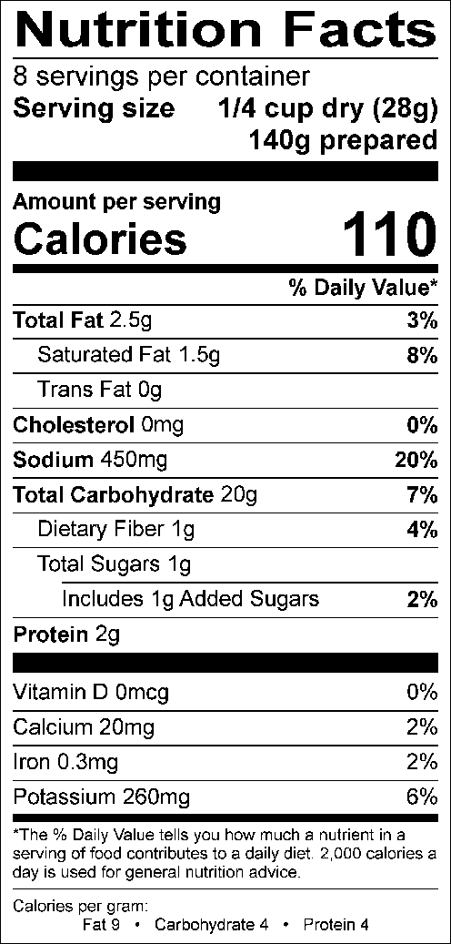

IV. FINISHED PRODUCT REQUIREMENTS

A. Packaged Product
1. Appearance- shall possess a bright, uniform white to creamy yellow potato color.
2. Defects- not more than 15 per 100 grams greater than 1/16".
3. Moisture- 8.0% maximum
4. Sulfite (as SO₂) 280 ± 120ppm
5. Bacteriological-

Standard Plate Count/g 50,000/gm maximum
Coliform/g 50/gm maximum
Yeast and Mold/g 100/gm maximum

B. Prepared Product
1. Appearance- typical cooked white potato color ranging from light cream to pale yellow. No objectionable darkening after preparation.
2. Texture- typical fluffy mashed potato texture free from gumminess, pastiness and lumps.
3. Flavor and Aroma- typical cooked potato with buttery and milky flavor and aroma notes. Free from objectionable foreign flavors or aromas.

C. Preparation
1. Measure 4 cups of boiling water into a serving bowl.

2. Add pouch of seasoned potatoes all at once, using a fork to moisten all potatoes. Let stand one minute.

3. Stir well and serve.
Note: For a creamier mashed potato add more boiling water.

V. PACKAGING
Product is packaged in a moisture and gas resistant poly pouch. The net weight per pouch is 8.0oz (226.8 grams), 8 pouches per box.

VI. STORAGE & SHELF LIFE INFORMATION
The shelf life is approximately 12 months from date of packaging code (imprinted on the package), when shipped and stored away from direct heat, in a cool, dry location, away from strong contaminating odors. Shipping and storage conditions should not exceed 80°F and 60% R.H.

VII. ALLERGENS
US – Milk INTERNATIONAL – Milk, Sulfites

VIII. CERTIFICATION
Dairy Kosher

